Comeback of high-precision solutions
ipf introduces the PT49-series of diffuse-reflection laser sensors

For years, the PT49-series of diffuse-reflection laser sensors was a constant in ipf's product range. In spring 2022, however, the devices had to be discontinued due to the unexpected setting of the production of important electronic components. ipf has now completely redeveloped the solutions.

With a view to the future supply of spare parts, ipf attached great importance to ensuring that both the external dimensions of the robust metal housing and the scratch-resistant glass front screen remain unchanged.

The directly parameterizable or externally teachable sensors can be set as usual in a sensing range of 50 to 550mm. Like its predecessor (PT490370), the PT499370 has a precise light spot with a diameter of 1.5mm. The PT499375, as the successor to the PT490375, projects a laser line with an approximate continuous height of a maximum of 1.04mm.

As a new function, the current laser triangulation probes from ipf now offer the option of dynamic teaching, which proves to be an extremely useful aid, especially for fast movement sequences.

The new PT49-series with background suppression or almost surface-independent object detection from ipf is ideal for high-precision inquiries even under harsh environmental conditions. The PT499375 with line optics is ideal for detecting objects with rough or structured surfaces, for example. Even with objects with a high degree of reflection, the solutions master the associated challenges for the sensor technology. This is why all devices have laser protection class 2 again.

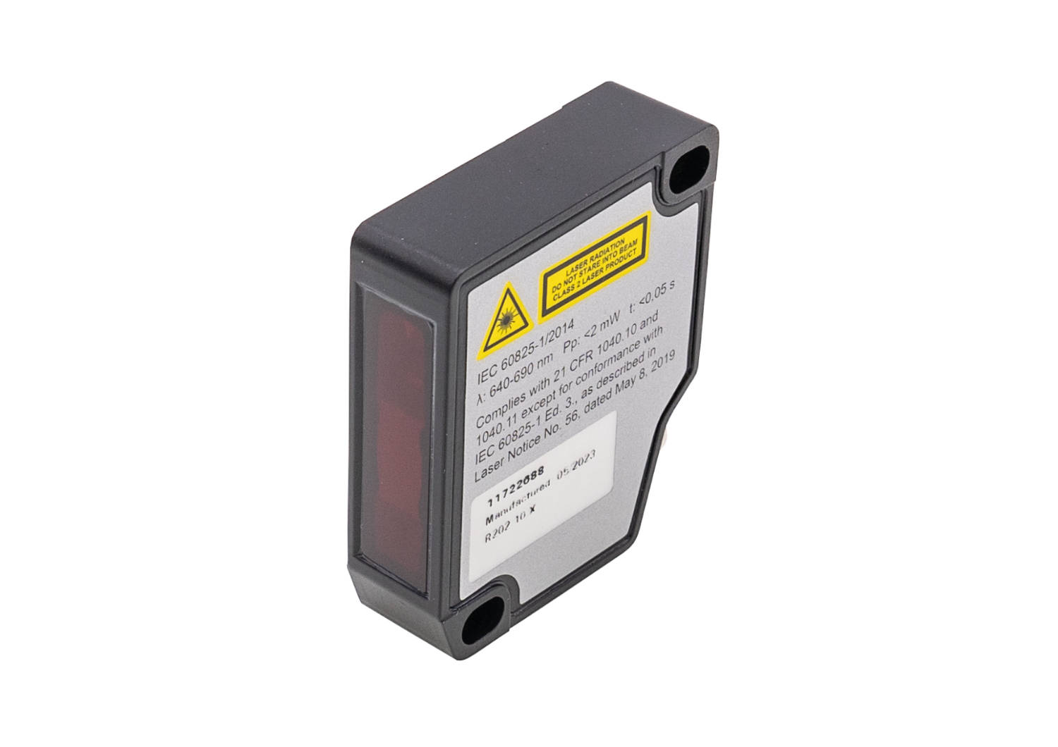

Image caption: Comeback of popular solutions: the new diffuse-reflection laser sensors
of the PT49-series from ipf, which also includes the PT499375 (pictured) with line optics.
(Image: ipf electronic gmbh)

ABOUT IPF ELECTRONIC
Sensors of the highest quality
When HIGH-TECH becomes HIGH-END

We have stood for high-performance sensors in automation technology in the German-speaking markets for over three decades. We prioritize the highest level of quality and have our own production at our headquarters in Altena in Sauerland.
We are ipf electronic and do more than just our job. We think outside the box, create innovative, sustainable solutions and remain approachable. We are based in Sauerland, one of the most innovative areas in Germany. Our products are precise, intelligent, technologically well-engineered and versatile. Our 140 employees live and breathe service, even outside of normal business hours.
Our wide range of products, great problem-solving skills and strong focus on service make us a unique top-supplier of industrial sensor technology. Permanent research and development play an equally substantial role as the education and training of employees and management. Our company, which was founded in 1982, is managed today by the family in the second generation. We apply special standards in environmental protection and sustainable resource management.

CONTACT
ipf electronic gmbh
Rosmarter Allee 14
58762 Altena
Germany
info@ipf-electronic.com
www.ipf-electronic.com


PRESS CONTACT
Martinus Menne
Waldweg 8 ● 57489 Drolshagen
Germany
Tel +49 2761 8288861
mm@technikredaktion.de
www.technikredaktion.de

